License Plate Detection Using Convolutional Neural Network–Back to the Basic With Design of Experiments
CHAPTER 1

INTRODUCTION

1.1 INTERNET OF THINGS

Internet of Things (IoT) gained a great attention from researchers, since it becomes an important technology that promises a smart human being life, by allowing a communication between objects, machines and every things together with peoples. IoT represents a system which consists a thing in the real world, and sensors attached to or combined to these things, connected to the Internet via wired and wireless network structure. The IoT sensors can use various types of connections such as RFID, Wi-Fi, Bluetooth, and ZigBee, in addition to allowing wide area connectivity using many technologies such as GSM, GPRS, 3G, and LTE.

IoT-enabled things will share information about the condition of things and the surrounding environment with people, software systems and other machines. by the technology of the IoT, the world will become smart in every aspects, since the IoT will provides a means of smart cities, smart healthcare, smart homes and building, in addition to many important applications such as smart energy, grid, transportation, waste management and monitoring. In this paper we review a concept of many IoT applications and future possibilities for new related technologies in addition to the challenges that facing the implementation of the IoT.

The Internet of Things (IoT), sometimes referred to as the Internet of Objects, will change everything including ourselves. The Internet has an impact on education, communication, business, science, government, and humanity. Clearly, the Internet is one of the most important and powerful creations in all

1

of human history and now with the concept of the internet of things, internet becomes more favorable to have a smart life in every aspects.

1.2 OBJECTIVE

To develop a system that recognizes vehicle license plate from a car.

1.3 OVERVIEW

Smart transportation and urban surveillance systems are important internet of things (IoT) applications for smart cities. In smart transportation and urban surveillance applications, cameras/imaging sensors are commonly installed to automatically detect and identify potential vehicles/cars through automated object detection methods. Usually, such automated object detection methods demand high-complexity image/data processing technologies and algorithms. Hence, the design of low-complexity automated object detection algorithms becomes an important topic in urban surveillance systems. Among these researches, both vehicle license plate recognition (VLPR) and vehicle recognition are hot research topics worldwide, which can be applied to many IoT applications, such as road traffic data.

It is known that a license plate number is a unique identification of a vehicle. Specifically, the license plate recognition, i.e. the extraction of a license plate region from an image, is the key module in a VLPR system, which influences the accuracy of the VLPR systems significantly. Different algorithms have been proposed for identifying a vehicle license plate using image processing. One typical way is vertical edge matching. The idea is to first locate the two vertical edges of a license plate, and hence to detect its four corners. In this way, the

2

license plate can be extracted accurately Using the contrast between the grayscale values, proposed a vertical edge based license plate recognition method.

Another technology is morphology based license plate detection. This method is to extract important features of contrast as guidance to search the license plates. In, to extract potential text information from the image, a method is proposed using adaptive threshold, fractal filter and morphological analysis. In and, edge statistics in combination with morphological approaches are proposed to eliminate the undesired edges in the images.

Color based methods are also attempted which make use of the colors of the vehicle license plate. In a color based method combined with the texture characteristics is proposed to try to detect license plate from the color image. In the combination of edge information and plate color are utilized to identify the vehicle license plates.

Based on neural network techniques, other recognition methods of vehicle license plates are proposed. These methods are designed to train classifiers to offer a proper response to the license plate images. In the authors apply genetic algorithm (GA) to the training process and combine the statistic features together with structure features. In a vehicle license plate detection method using neural network approaches is proposed. The proposed scheme utilizes a neural network chip named as CogniMem to detect the vehicle license plates. In authors using wavelet transform technique to decompose the images into different layers, and then utilize the low frequency images to combine with neural network technique.

3
CHAPTER 2

SYSTEM DESIGN AND IMPLEMENTATION 2.1 LITERATURE SURVEY

1)A vehicle license plate recognition system based on analysis of maximally stable external regions.

AUTHORS : B.Li,B.Tian,Q.yao,k.Wang

PUBLICATIONS : 2012

DESCRIPTION :

Vehicle License Plate Recognition (VLPR) system is a core module in Intelligent Transportation Systems (ITS). A VLPR system is proposed. Considering that license plate localization is the most important and difficult part in VLPR system, we present an effective license plate localization method based on analysis of Maximally Stable Extremal Region (MSER) features. Firstly, MSER detector is utilized to extract candidate character regions. Secondly, the exact locations of license plates are inferred according to the arrangement of characters in standard license plates. The advantage of this license plate localization method is that less assumption of environmental illumination, weather and other conditions is made. After license plate localization, we continue to recognize the license plate characters and color to complete the whole VLPR system. Finally, the proposed VLPR system is tested on our own collected dataset. The experimental results show the availability and effectiveness of our VLPR system in locating and recognizing all the explicit license plates in an image.

4

2)A vision of IoT: Applications,Challenges,and opportunities with china perspective.

AUTHORS : S. Chen, H. Xu, D. Liu, B. Hu, H. Wang,

PUBLICATIONS : 2014

DESCRIPTION :

Internet of Things (IoT), which will create a huge network of billions or trillions of “Things” communicating with one another, are facing many technical and application challenges. It introduces the status of IoT development in China, including policies, R&D plans, applications, and standardization. With China's perspective,It depicts such challenges on technologies, applications, and standardization, and also proposes an open and general IoT architecture consisting of three platforms to meet the architecture challenge.Finally,It discusses the opportunity and prospect of IoT.

3)A new recognition method of vehicle license plate based on genetic neural network.

AUTHORS : G. Sun, C. Zhang, W. Zou, G. Yu,

PUBLICATIONS : 2010

DESCRIPTION :

A new recognition method of vehicle license plates based on neural network is presented in it. For the Back Propagation (BP) neural network often trap into the local minimum in the training process, a Genetic Neural Network (GNN), GABP was constructed by combining the Genetic Algorithm(GA)with BP neural network. The training of the GABP neural network was finished in two steps. The GA was

5

firstly used to make a thorough searching in the global space for the weights and thresholds of the neural network, which can ensure they fall into the neighborhood of global optimal solution. Then, in order to improve the convergence precision, the gradient method was used to finely train the network and find the global optimum or second-best solution with good performance. On the other side, feature extraction is also important for improving the recognition rate of the network. So both the structure features and the statistic features are used here, which include mesh feature, direction line element feature and Zernike moments feature. Experimental results show that the proposed method can save the time of training network and achieve a highly recognition rate.

4)Vehicle-license-plate recognition based on neural networks

AUTHORS : Y. Liu, D. Wei, N. Zhang, M. Zhao,

PUBLICATIONS : 2011

DESCRIPTION :

A license plate recognition system based on neural networks was designed and developed. The system used a neural-network chip to recognize license plates. The chip combined video image processing module with neural network module by using equalized image processing algorithm and network classification algorithm. A set of interface circuit was developed for implementing license-plate-number recognition. Experiment results show the system can guarantee a very low error rate at an acceptable recognition time.

6

5)Manifold and transfer subspace learning for cross-domain recognition in dynamic systems

vehicle

AUTHORS

: O. Mendoza-Schrock, M. Rizki, V. Velten,

PUBLICATIONS : 2015

DESCRIPTION :

Transfer Subspace Learning has gained recent popularity in the literature for its ability to perform cross-dataset and cross-domain object recognition - enablers for data fusion. The ability to leverage existing data without the need for additional data collections is attractive for Automatic Target Recognition applications. For Automatic Target Recognition (or object assessment) applications, Transfer Subspace Learning is a game changer for dynamic systems, as it enables the incorporation of sparse and dynamically collected data into existing systems that utilize large, dense databases. A baseline Transfer Subspace Learning technique is the Transfer Fisher's Linear Discriminative Analysis, an approach based on Bregman divergence-based regularization. It modifies the implementation of the Transfer Fisher's Linear Discriminative Analysis technique by combining it with Manifold Learning and adjusting it to allow for a more systematic search of tuning parameters. Specifically, the Diffusion Map approach is utilized, a Manifold Learning approach based on heat diffusion. The modified technique is then utilized for cross-data and cross-domain electro-optical vehicle recognition.

7

2.2 SYSTEM ANALYSIS

2.2.1 EXISTING SYSTEM

- The techniques based upon combinations of edge statistics and mathematical morphology has been proven to give good results. Typically in these methods, gradient magnitude and their local variance in an image are computed.

- They are based on the property that the brightness change in the license plate region is more prominent and easily detectable than otherwise.

- Then, regions with a high edge magnitude and high edge variance are identified as possible license plate regions.

2.2.1.1 DISADVANTAGES

- A disadvantages is that edge-based methods alone can hardly be applied to complex images, since they are too sensitive to unwanted edges, which may also show high edge magnitude or variance.

- The authors use Daubechies wavelet transform method to calculate the vertical and horizontal frequency energy curves, considering the frequency is the highest near the number plate.

- The transfer subspace learning technique with the manifold learning approach to allow a more systematic search of tuning parameters for the purposes of cross-data and cross-domain electro-optical vehicle recognition.

8
2.2.2 PROPOSED SYSTEM

- The algorithm proposed here is designed to recognize license plates of vehicles automatically.

- Input of the system is the image of a vehicle captured by a camera. The captured image taken from 4-5 meters away is processed through the license plate extractor with giving its output to segmentation part.

- It designs a novel filter which is unified to detect either the vehicle license plates or the vehicles from the digital camera imaging sensors of urban surveillance systems in smart cities.

- The first to design this kind of filter to detect the vehicle/license plate objects.

- The results show that our filter can automatically detect the highest energy frequency areas out from the images, which makes our proposed algorithm a simple and effective method to automatically detect vehicle objects for IoT and smart cities applications.

2.2.2.1 ADVANTAGES

- Number plate extraction needs extremely high accuracy when working on images of busy roads.

- This method can also be used to reduce the big data volume which is generated every day from urban surveillance systems.

- Our method can also be used to reduce the big data volume which is generated every day from urban surveillance systems in smart cities.

9
- 3 SYSTEM SPECIFICATION

2.3.1 HARDWARE REQUIREMENTS

  - Power supply

  - Microcontroller

  - GSM/GPRS

  - MAX232/RS232

  - IOT Device (GPRS Modem)

  - Driver Circuit (ULN2003a)

  - Relay

  - Load

  - LCD Display

2.3.2 SOFTWARE REQUIREMENTS

- Embedded C

- MPLABIDE

- MATLAB

10
2.3.3 SOFTWARE DESCRIPTION

2.3.3.1 MATLAB

MATLAB is a high-performance language for technical computing. It integrates computation, visualization, and programming in an easy-to-use environment where problems and solutions are expressed in familiar mathematical notation.

Typical uses include:

- Math and computation

- Algorithm development

- Modeling, simulation, and prototyping

- Data analysis, exploration, and visualization

- Scientific and engineering graphics

- Application development, including Graphical User Interface building

MATLAB is an interactive system whose basic data element is an array that does not require dimensioning. This allows you to solve many technical computing problems, especially those with matrix and vector formulations, in a fraction of the time it would take to write a program in a scalar non-interactive language such as C or FORTRAN.

MATLAB

MATLAB = Matrix Laboratory

MATLAB is a high-level language and interactive environment that enable to perform computationally intensive tasks faster than with traditional programming languages such as C, C++ and Fortran

11

It integrates computation, visualization, and programming in an easy-to-use environment where problems and solutions are expressed in familiar mathematical notation.

Typical uses include:

- Math and computation

- Algorithm development

- Modeling, simulation, and prototyping

- Data analysis, exploration, and visualization

- Scientific and engineering graphics

- Application development, including graphical user interface building

- MATLAB has several advantages over other methods or languages:

Its basic data element is the matrix. A simple integer is considered an matrix of one row and one column. Several mathematical operations that work on arrays or matrices are built-in to the Matlab environment. For example, cross-products, dot-products, determinants, inverse matrices.

- Vectorized operations. Adding two arrays together needs only one command, instead of a for or while loop.

- The graphical output is optimized for interaction. You can plot your data very easily, and then change colors, sizes, scales, etc, by using the graphical interactive tools.

- MATLAB’s functionality can be greatly expanded by the addition of toolboxes.

These are sets of specific functions that provided more specialized functionality.Example: Excel link allows data to be written in a format

12

recognized by Excel, Statistics Toolbox allows more specialized statistical manipulation of data (Anova, Basic Fits, etc)

MATLAB System

The MATLAB system consists of five main parts:

Development Environment

This is the set of tools and facilities that help you use MATLAB functions and files. Many of these tools are graphical user interfaces. It includes the MATLAB desktop and Command Window, a command history, and browsers for viewing help, the workspace, files, and the search path.

The MATLAB Mathematical Function Library

This is a vast collection of computational algorithms ranging from elementary functions like sum, sine, cosine, and complex arithmetic, to more sophisticated functions like matrix inverse, matrix eigenvalues, Bessel functions, and fast Fourier transforms.

The MATLAB Language

This is a high-level matrix/array language with control flow statements, functions, data structures, input/output, and object-oriented programming features. It allows both "programming in the small" to rapidly create quick and dirty throw-away programs, and "programming in the large" to create complete large and complex application programs.

Handle Graphics

This is the MATLAB graphics system. It includes high-level commands for two-dimensional and three-dimensional data visualization, image processing, animation, and presentation graphics. It also includes low-level commands that

13

allow you to fully customize the appearance of graphics as well as to build complete graphical user interfaces on your MATLAB applications.

The MATLAB Application Program Interface (API).

This is a library that allows you to write C and FORTRAN programs that interact with MATLAB. It include facilities for calling routines from MATLAB (dynamic linking), calling MATLAB as a computational engine, and for reading and writing MAT-files.

2.3.3.2 IMAGES IN MATLAB

When working with images in Matlab, there are many things to keep in mind such as loading an image, using the right format, saving the data as different data types, how to Display an image, conversion between different image formats, etc. The following image formats are supported by Matlab:

BMP,HDF,JPEG,PCX,TIFF,XWB

Most images you find on the Internet are JPEG-images which is the name for one of the most widely used compression standards for images.

IMAGE PROCESSING TOOLBOX

The Image Processing Toolbox is a collection of functions that extend the capabilities of the MATLAB’s numeric computing environment. The toolbox supports a wide range of image processing operations, including:

- Image enhancement, filtering, and deblurring

- Image analysis, including segmentation, morphology, feature extraction, and measurement

- Geometric transformations and intensity-based image registration methods

14
- Image transforms, including FFT, DCT, Radon, and fan-beam projection

- Workflows for processing, displaying, and navigating arbitrarily large images

- Interactive tools, including ROI selections, histograms, and distance measurements

- DICOM file import and export

Application development tools.

Image Processing

Signal Processing

Control System

Communications

Neural Network

Instrument Control

Aerospace

Fuzzy Logic

Embedded mat lab

The different levels at which one may want to interact with the system

- User interface

- Running the GUI

- Creation of batch jobs for applications using Matlab batch

Batch management, batch execution, including use of MATLAB scripts to run batch jobs on multiple datasets with very little user interaction

15
Application development

- Requirements on code structure of application

- Introduction to internal representation of batch configurations

- Introduction to writing batch configuration scripts

- Integration of an application into configuration management and GUI

Implementation

- Classes used

- Methods

- Details about job management, runtime etc.

2.3.3.3 FUNDAMENTAL IN DIGITAL IMAGE PROCESSING

The various basic steps are as follows

- Image Acquisition

- Image preprocessing

- Image segmentation

- Image Representation and Description

- Image Recognition and Interpretation and

- Knowledge base.

16
IMAGE ACQUISITION

In the process, the first step in the process is image acquisition→that is, to acquire a digital image. It highly requires an imaging sensor and the capability to digitize the signal produced by the sensor.

The sensor could be a monochrome or color TV camera that produces an entire image of the problem domain every 1/30 sec.

The imaging sensor could also a line-scan camera that produces a single image line at a time. In this case, the object’s motion past the line scanner produces two-dimensional image. If the output of the camera or other imaging sensor is not already in digital form, an analog-to-digital converter digitizes it. The nature of the sensor and image it produces are determined by the application.
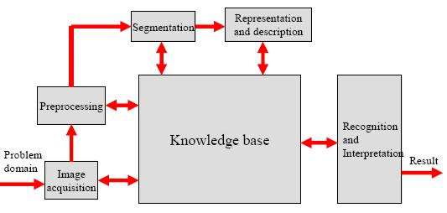

Fig 2.1 Fundamental steps in digital image processing

17
IMAGE PREPROCESSING

The key function of preprocessing is to improve the image in ways-that increase the chances for success of the other processes. Preprocessing typically deals with techniques for enhancing contrast, removing noise, and isolating regions whose texture indicate a likelihood of alphanumeric information.

1.Image Enhancement:

- More suitable than original image for a specific application.

2.Image Restoration:

• A process that attempts to reconstruct or recover an image that has been degraded using prior knowledge of the degradation concept.

IMAGE SEGMENTATION

The next stage deals with segmentation. Segmentation partitions an input image into its small constituent parts or objects. In general, autonomous segmentation is one of the most difficult tasks in digital image processing. On the one hand, a rugged segmentation procedure brings the process a long way towards the successful solution of an imaging problem. On the other hand, weak or erratic segmentation algorithms almost guarantee eventual failure.

In terms of character recognition, the key role of segmentation is to extract individual characters and words from the background.

IMAGE REPRESENTATION AND DESCRIPTION

The output of the segmentation stage usually is raw pixel data, constituting either the boundary of a region or all the points in the region itself. In either case converting the data to a form suitable for computer processing is necessary.

18

The first decision that must be made, whether the data should be represented as a boundary or as a complete region. Boundary representation is appropriate when the focus is on external shape characteristics, such as corners and inflections.

Regional representation is appropriate when the focus is on internal properties, such as texture or skeletal shape. In some applications, however, these representations coexist.

This situation occurs in character recognition applications, which often require algorithms based on boundary shape as well as skeletons and other internal properties.

IMAGE RECOGNITION AND INTERPRETATION

Recognition is the process that assigns a label to an object based on the information provided by its descriptors. Interpretation involves assigning meaning to an ensemble of recognized objects.

For example, identifying a character as, say, c requires associating the descriptors for that character with the label c.

Interpretation attempts to assign meaning to a set of labeled entities. For example, a string of five numbers are followed by a hyphen and four more numbers can be interpreted to be a ZIP code.

KNOWLEDGE BASE

Based on the above Discussion, the need for prior knowledge and or about the interaction between the knowledge base and the processing modules in Fig.2.1. Knowledge about a problem domain is coded into an image processing system in the form of a knowledge database. This knowledge may be as simple as detailing regions

19

of an image where the information of interest is known to be located, thus limiting the search that has to be conducted in seeking that information.

The knowledge base also can be quite complex, such as an interrelated list of all major possible defects in a materials inspection problem or an image database containing high-resolution satellite images of a region in connection with change-detection applications. In addition to guiding the operation of each processing module, the knowledge base also controls the interaction between modules.

DIGITAL IMAGE PROCESSING:

Digital image processing is the use of computer algorithms to perform image processing on digital images. As a subfield of digital signal processing, digital image processing has many advantages over analog image processing; it allows a much wider range of algorithms to be applied to the input data, and can avoid problems such as the build-up of noise and signal distortion during processing.

Types of Digital Image

For photographic purposes, there are two important types of digital images: color and grayscale. Color images are made up of colored pixels while grayscale images are made of pixels in different shades of gray .

Grayscale Images:

A grayscale image is made up of pixels, each of which holds a single number corresponding to the gray level of the image at a particular location. These gray levels span the full range from black to white in a series of very fine steps, normally 256 different grays. Assuming 256 gray levels, each black and white pixel can be stored in a single byte (8 bits) of memory.

20
Color Images:

A color image is made up of pixels, each of which holds three numbers corresponding to the red, green and blue levels of the image at a particular location. Assuming 256 levels, each color pixel can be stored in three bytes (24 bits) of memory. Note that for images of the same size, a black & white version will use three times less memory than a color version.

Binary Images:

Binary images use only a single bit to represent each pixel.Since a bit can only exist in two states- ON or OFF, every pixel in a binary image must be one of two colors, usually black or white. This inability to represent intermediate shades of gray is what limits their usefulness in dealing with photographic images.

2.3.3.4 SYSTEM IMPLEMENTATION:

System Implementation is the stage in the project where the theoretical design is turned into a working system. The most critical stage is achieving a successful system and in giving confidence on the new system for the user that it will work efficiently and effectively.

The existing system was long time process. The proposed system was developed using C#.NET. The existing system caused long time transmission process but the system developed now has a very good user-friendly tool, which has a menu-based interface, graphical interface for the end user.

After coding and testing, the project is to be installed on the necessary system. The executable file is to be created and loaded in the system. Again the code

21

is tested in the installed system. Installing the developed code in system in the form of executable file is implementation.

After coding and testing, the project is to be installed on the necessary system. The executable file is to be created and loaded in the system. Again the code is tested in the installed system. Installing the developed code in system in the form of executable file is implementation.

There are used two system server and client. All user credential stored in the server. User login and manipulate process from remote place via client system.

22

2.3 SYSTEM ARCHITECTURE
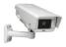

Surveillance camera
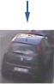

Surveillance Image
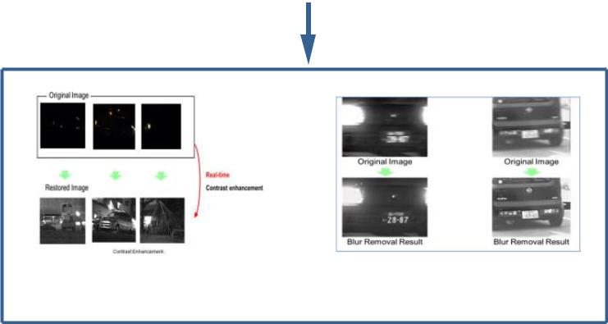

Filter

Increase contrast of | blur removal of image
image | blur removal of image
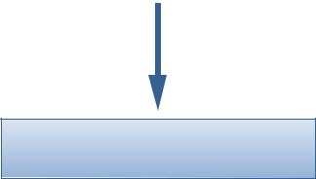

image segmentation

Next Traffic signal
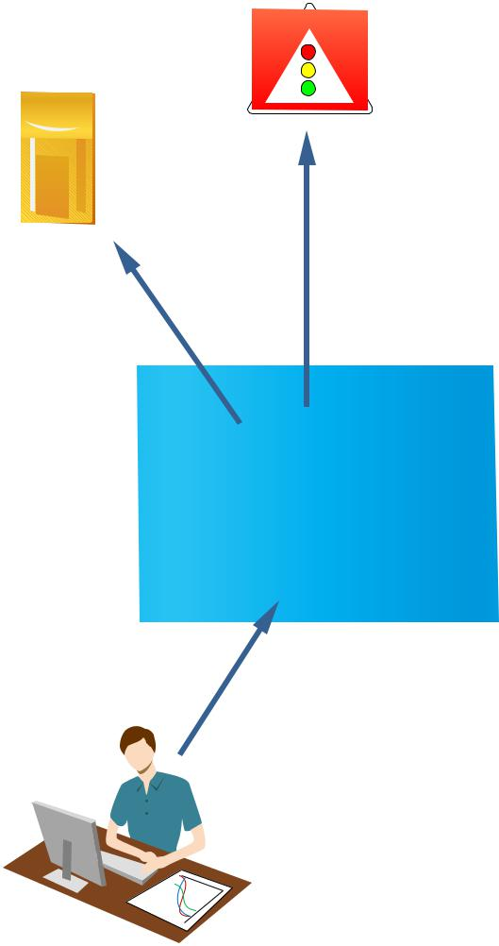

Database
Vehicle No

Vehicle No

IOT

Data Monitoring

Fig 2.2 Architecture diagram

23

2.5 UML DIAGRAM

2.5.1 Use case diagrams

Use case diagram overview the usage requirement for system. It is useful for the presentation to management and /or project stake holders, but for actual development you will find the use case provide significantly more value because it describe “the meant” of the actual requirement use case describe a sequence of action that provide something of measurable value to an action and is drawn as a horizontal ellipse.
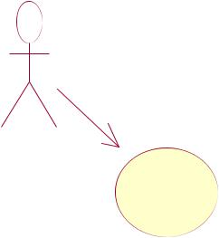
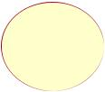

Next traffic signal


camera
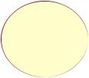

surveilance images | IOT
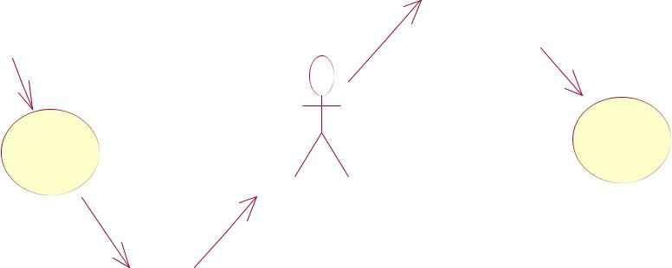

Filter | data monitoring | database
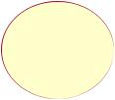

Image sagmentation

Fig 2.3 Use case diagram

24

2.5.2 ACTIVITY DIAGRAM

Activity diagrams are graphical representation of work flow of step wise activities and action with support for choice iteration and concurrency.The activity diagrams can be used to describe the business and operational step by step work flow of components in a system. It consists of initial node,activity final node and activities in between.
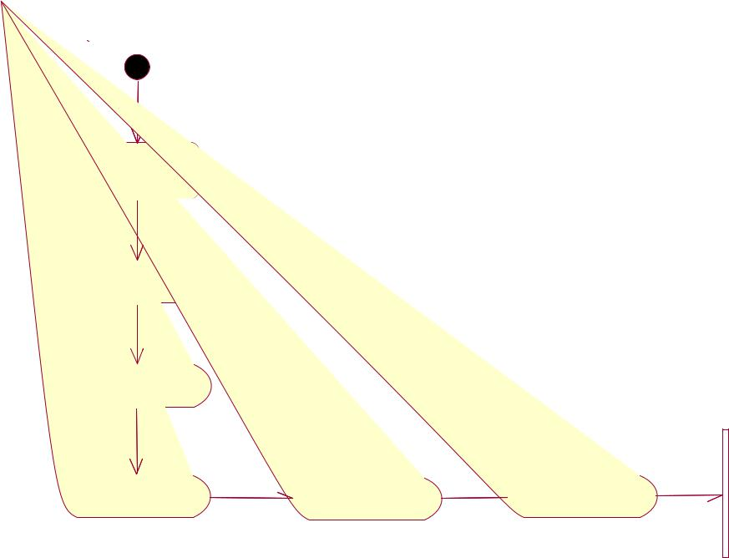

Camera

Surveilance

Image

Filtering
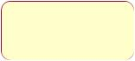
Database

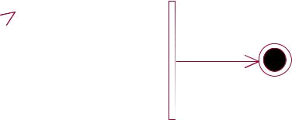

Image

Sagmentation

Data

Monitoring

IOT

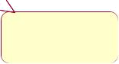

Next traffic

signal

Fig 2.4 Activity diagram

25

2.5.3 SEQUENCE DIAGRAM

Sequence diagram model the flow of logic within a system in a visual manner,enabling you both to document and validating a logic and commonly used for both design and analysis purpose.Sequence diagram are most popular UML artifact for dynamic modeling, which focuses on identifying the behavior within your system.

camera |  |  |  |  |  |  |  | image |  |  |  |  |  |  |  |  |  |  |  | iot |  |  | database |  |  |  | next traffic
 |  |  |  |  |  | sagmentation |  |  |  |  |  |  |  |  |  |  |  |  |  |  |  |  |  |  |  |  |  | signal
 |  |  |  |  | image
 |  |  |  |  |  |  |  |  |  |  |  |  |  | filtering
 |  |  |  |  |  |  | image agmentation
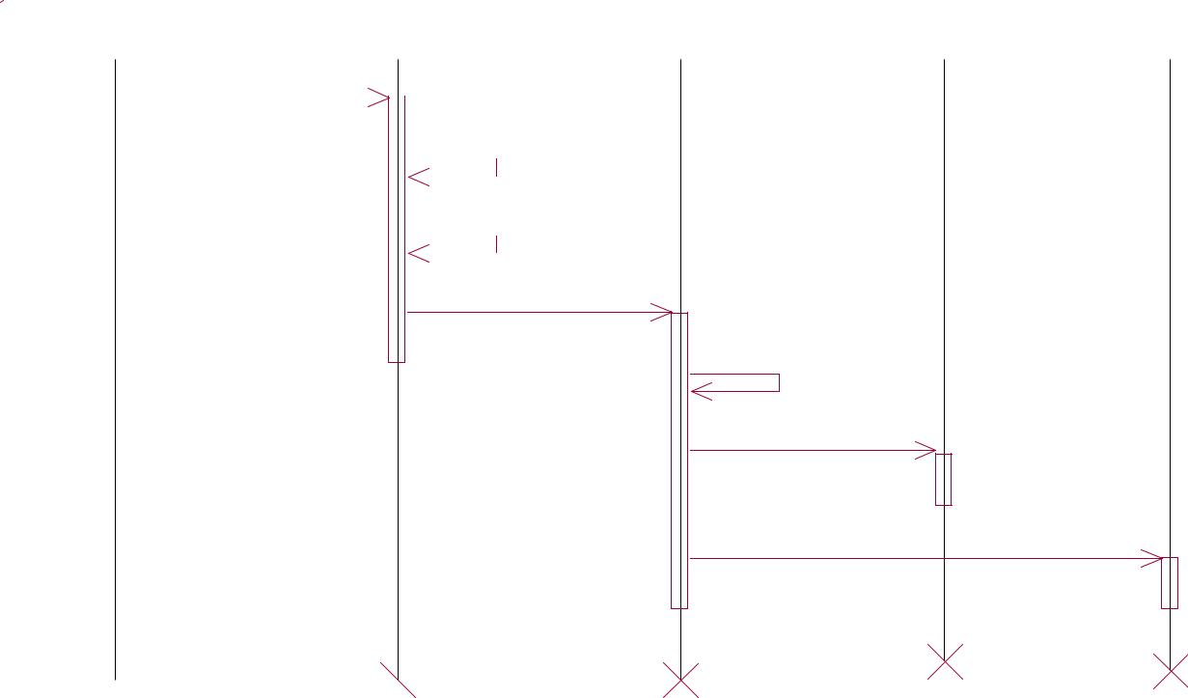

monitoring

details send to database

details send to next traffic signal

Fig 2.5 Sequence diagram

26

2.5.4 COLLABORATION DIAGRAM

Another type of interaction diagram is the collaboration diagram.A collaboration diagram represents the collaboration,which asset of objects related in a particular context and interaction which a set of message exchange among the objects within the collaboration to achieve deserved outcome.

 | 2: filtering |  | next traffic
 | 3: image agmentation | 5: monitoring | next traffic
 | 3: image agmentation | 5: monitoring | signal
 |  | 7: details send to next traffic signal
 | 1: image | 4:
camera | image | iot
 | sagmentation
 |  |  | 6: details send to database
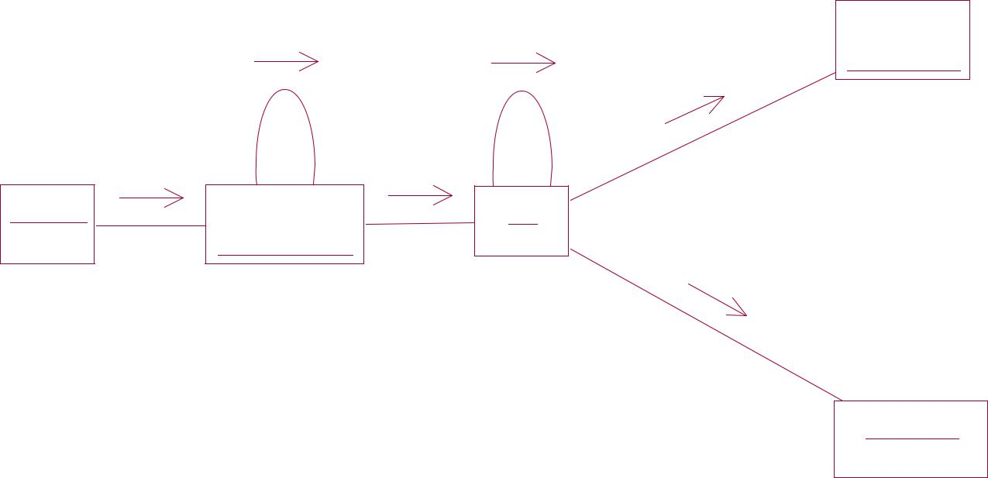

database

Fig 2.6 collaboration diagram

27

2.6 MODULES:

- Input raw image

- Noise reduction

- Preprocessing

- Image segmentation

2.6.1 Input raw image

Input the image that is taken from the car

2.6.2 Noise reduction

We used median filtering method to reduce the paper and salt noise. We have used 3x 3 masks to get eight neighbors of a pixel and their consistent gray value.

Contrast enhancement using histogram equalization:

Using histogram equalization method the difference of each image is being enhanced. The function used to improvement that is J=histeq(k); histeq enhances the contrast of the images by converting the values in an intensity image. When image pixel intensity of 8-neibourgh connectivity, we supply a preferred histogram, histeq chooses the grayscale conversion T to minimize

│c1 (T (k))-c0 (k) │

In b elow we state the change of histogram from original image and after smearing the contrast enhancement using histogram equalization.

28

Character Segmentation

Matlab toolbox function delivers a function called region props(). It measures a set of properties for each labeled region in the label matrix. We use bounding box to measure the properties of the image region. After labeling the connecting components, the region will be removing from the input image.

2.6.3 Preprocessing

The preprocessing phase consists of conventional techniques for example image filtering, improving the visibility of the image and some enhancement in image. Some of the basic filters are applied on the area of number plate that is Histogram Equalization, Median filter and Morphological filters

Histogram equalization is one of the most important part of the software for any image processing. It improves contrast and the goal of histogram equalization is to obtain a uniform histogram. This technique is used on a whole image.

The median filter is normally used to reduce noise in an image; it often does a better job than the mean filter of preserving useful detail in the image. Median filtering is a simple and very effective noise removal filtering process. Its performance is particularly good for removing shot noise. Shot noise consists of strong spike like isolated values. This class of filter belongs to the class of edge preserving smoothing filters which are non-linear filters. This filter smooths the data while keeping the small and sharp details.

29
Filtering of digits

Now the black and white image of the Vehicle number Plate can be obtained. It has been cropped to a rectangular shape in which it enhances the algorithm to be more uniformed in the further stages. The non-digits substance which appears in the image is caused by the noise (quantization that will transform to „Black‟), object or substance which is not digits/characters such as screws, sand, water droplet, frame lines, effects on JPEG compression.

By Filtering, the unwanted substances or noise can be removed or filtered out that is not a character or digits. Lastly, the image is only left with characters and digits in which we are interested.

The 2 stages for the algorithm is as follows:

  - Remove out the small objects or connected components.

- Identify the frame line that is connected to the digits and separate it. Identify and remove away the small connected objects

2.6.4 Image segmentation

In order to extract and analyzed the object characteristic, image segmentation is used,the process which need to partition the image into different parts that will have a strong correlation with the objects.

Segmentation process can be categorized into several parts.Firstly is the global knowledge of an image. The feature of the image is represented by a histogram. Secondly, in the boundary-based segmentation edge detection is used to obtain the region contours and the objects will construct from the obtain contours. Another one

30

is edge-based segmentation. For this paper, first category segmentation method is being used which is by using threshold.

Database

It is a collection of information or data which it is being orderly organize, thus it can be accessed easily and updated. Database can be in the form of text, contents and images and is needed to make sure that the image space can contained enough characters which have been extracted and the vehicle number plate number stored in the excel sheet for the purpose of comparison. The database would be large enough in order to improve the accuracy and better chances of obtaining the correct result. The class recognition will check if the computed ratio is correct. It will ignore the class if the image thresholding is too low. If the class has match correctly, it will be compare with data set in the predefined database and provide an output if the image is recognized correctly.

Character recognition

In this step, the extracted characters are resized to fit the characters into a window. For the paper, each character is normalized to the size of (50x30) binary image and then follow by reshape to standard dimension before sending the data set to neural network for training. Its performance is particularly good for removing shot noise. Shot noise consists of strong spike like isolated values. This class of filter belongs to the class of edge preserving smoothing filters which are non-linear filters. This filter smooths the data while keeping the small and sharp details.

31
2.7 TESTING

2.7.1 PROCESS

The purpose of testing is to discover errors. Testing is the process of trying to discover every conceivable fault or weakness in a work product. It provides a way to check the functionality of components,sub assemblies, assemblies and/or a finished product it is the process of exercising software with the intent of ensuring that the Software system meets its requirements and user expectations and does not fail in an unacceptable manner..

2.7.2 TYPES OF TESTING

2.7.2.1 UNIT TESTING

Unit testing involves the design of test cases that validate that the internal program logic is functioning properly, and that program input produces valid outputs. All decision branches and internal code flow should be validated. It is the testing of individual software units of the application .it is done after the completion of an individual unit before integration. This is a structural testing, that relies on knowledge of its construction and is invasive. Unit tests perform basic tests at component level and test a specific business process, application, and/or system configuration.
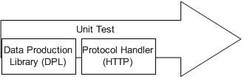

Fig 2.6 Unit testing

32
2.7.2.2 INTEGRATION TESTING

Integration tests are designed to test integrated software components to determine if they actually run as one program. Testing is event driven and is more concerned with the basic outcome of screens or fields. Integration tests demonstrate that although the components were individually satisfaction, as shown by successfully unit testing, the combination of components is correct and consistent. Integration testing is specifically aimed at exposing the problems that arise from the combination of components.

2.7.2.3 FUNCTIONAL TESTING

Functional tests provide systematic demonstrations that functions tested are available as specified by the business and technical requirements, system documentation and user manuals.

Functional testing is centered on the following items:

- Valid Input: identified classes of valid input must be accepted.

- Invalid Input: identified classes of invalid input must be rejected.

- Functions: identified functions must be exercised.

- Output: identified classes of application outputs must be exercised.

- Systems/Procedure: interfacing systems or procedures must be invoked.

33
2.7.2.4 SYSTEM TESTING

System testing ensures that the entire integrated software system meets requirements. It tests a configuration to ensure known and predictable results. An example of system testing is the configuration oriented system integration test. System testing is based on process descriptions and flows, emphasizing pre-driven process links and integration points.

2.7.2.5 WHITE BOX TESTING

White Box Testing is a testing in which the software tester has knowledge of the inner workings, structure and language of the software, or at least its purpose. It is used to test areas that cannot be reached from a black box level.Tests perform basic tests at component level and test a specific business process, application, and/or system configuration. Unit tests ensure that each unique path of a business process performs accurately to the documented specifications.
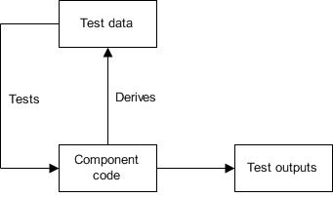

Fig 2.8 White box testing

34
2.7.2.6 BLACK BOX TESTING

Black Box Testing is testing the software without any knowledge of the inner workings, structure or language of the module being tested. Black box tests, as most other kinds of tests, must be written from a definitive source document, such as specification or requirements document, such as specification or requirements document. It is a testing in which the software under test is treated, as a black box

.you cannot “see” into it. The test provides inputs and responds to outputs without considering how the software works.
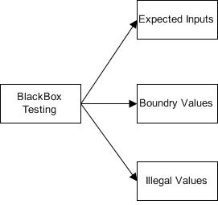

Fig 2.9 Black box testing

2.7.2.7 Acceptance Testing

User Acceptance Testing is a critical phase of any project and requires significant participation by the end user. It also ensures that the system meets the functional requirements.

35
2.7.2.8 Alpha Test

In software development, your alpha test, will be a test among yourselves (the teams) to confirm that your product works. Originally, the term alpha test meant the first phase of testing in a software development process. The first phase includes unit testing, component testing, and system testing. During this time you will compress files, edit for misspelled words and unclear directions, broken links, and sync audio and video. You will also test your make sure download times are acceptable and preloaders work.

2.7.2.9 Beta Test

In software development, a beta test is the second phase of software testing in which a sampling of the intended audience tries the product out. Beta testing can be considered "pre-release testing." Beta test versions of software are now distributed to curriculum specialists and teachers to give the program a "real-world" test and partly to provide a preview of the next release.

36
CHAPTER 3

CONCLUSION AND FUTURE ENHANCEMENT

3.1 CONCLUSION

The designs a novel filter which is unified to detect either the vehicle license plates or the vehicles from the digital camera imaging sensors of urban surveillance systems in smart cities. To the best of our knowledge, we are the first to design this kind of filter to detect the vehicle/license plate objects. We tested our filter with different images. The results show that our filter can automatically detect the highest energy frequency areas out from the images, which makes our proposed algorithm a simple and effective method to automatically detect vehicle objects for IoT and smart cities applications. It can also be used to reduce the big data volume which is generated every day from urban surveillance systems in smart cities.

37
3.2 FUTURE ENHANCEMENT

The future work can be semantically analyzing the word. The approaches is used for improving the accuracy of the reviews.Providing some additional theoretical understanding of what algorithmic and data characteristic can lead to larger versus smaller improvement in recommendation. For these VLPR algorithmic approaches is an important direction for future works.Another interesting direction would be to perform user behavior studies to investigate the value of stable recommendation on user.

38
APPENDIX 1

SOURCE CODE

clc

close all;

clear;

load imgfildata;

[file,path]=uigetfile({'*.jpg;*.bmp;*.png;*.tif'},'Choose an image');

s=[path,file];

picture=imread(s);

[~,cc]=size(picture);

picture=imresize(picture,[300 500]);

if size(picture,3)==3

picture=rgb2gray(picture);

end

- se=strel('rectangle',[5,5]);

- a=imerode(picture,se);

- figure,imshow(a);

- b=imdilate(a,se);

threshold = graythresh(picture);

picture =~im2bw(picture,threshold);

picture = bwareaopen(picture,30);

imshow(picture)

if cc>2000

39
picture1=bwareaopen(picture,3500);

else

picture1=bwareaopen(picture,3000);

end

figure,imshow(picture1)

picture2=picture-picture1;

figure,imshow(picture2)

picture2=bwareaopen(picture2,200);

figure,imshow(picture2)

[L,Ne]=bwlabel(picture2);

propied=regionprops(L,'BoundingBox');

hold on

pause(1)

for n=1:size(propied,1)

rectangle('Position',propied(n).BoundingBox,'EdgeColor','g','LineWidth',2)

end

hold off

figure

final_output=[];

t=[];

for n=1;

[r,c] = find(L==n);

n1=picture(min(r):max(r),min(c):max(c));

n1=imresize(n1,[42,24]);

imshow(n1)

40
pause(0.2)

x=[ ];

totalLetters=size(imgfile,2);

for k=1:totalLetters

y=corr2(imgfile{1,k},n1);

x=[x y];

e2nd

t=[t max(x)];

if max(x)>.45

z=find(x==max(x));

out=cell2mat(imgfile(2,z));

final_output=[final_output out];

end

end

file = fopen('number_Plate.txt', 'wt');

fprintf(file,'%s\n',final_output);

fclose(file);

winopen('number_Plate.txt')

function np=number_plate(img)

%image correlation method

%matches 2 matrix

41
load('imgfildata.mat');

[~,cc]=size(img);

picture=imresize(img,[300 500]);

if size(picture,3)==3

picture=rgb2gray(picture); %grey values are btwn 0 to 1 or 0 to 255 end

threshold = graythresh(picture); %greythresh gives the threshold value of greyscale image

picture =~im2bw(picture,threshold); %black nd white values are 0 or 1 and values greater thn threshold=1,rest=0 and invert white and black ie 1 to 0 and 0 to 1 picture = bwareaopen(picture,30); % those things that have less than 30 pixels are removed

if cc>2000

picture1=bwareaopen(picture,3500); %those things that have less than 3500 pixels are removed ie excluding nmbr plate

else

picture1=bwareaopen(picture,3000);

end

picture2=picture-picture1;

picture2=bwareaopen(picture2,200

[L,Ne]=bwlabel(picture2); %l gives matrix which has info of nmbr plate and Ne gives number of digits or characters

42

final_output=[];

t=[];

for n=1:Ne

[r,c] = find(L==n);

n1=picture(min(r):max(r),min(c):max(c n1=imresize(n1,[42,24

x=[ ];

totalLetters=size(imgfile,2);

for k=1:totalLetters

y=corr2(imgfile{1,k},n1);

x=[x y];

end

if max(x)>.35

z=find(x==max(x));

out=cell2mat(imgfile(2,z));

final_output=[final_output out];

end

end

np=final_output;

end

43

APPENDIX 2

SCREEN SHOTS
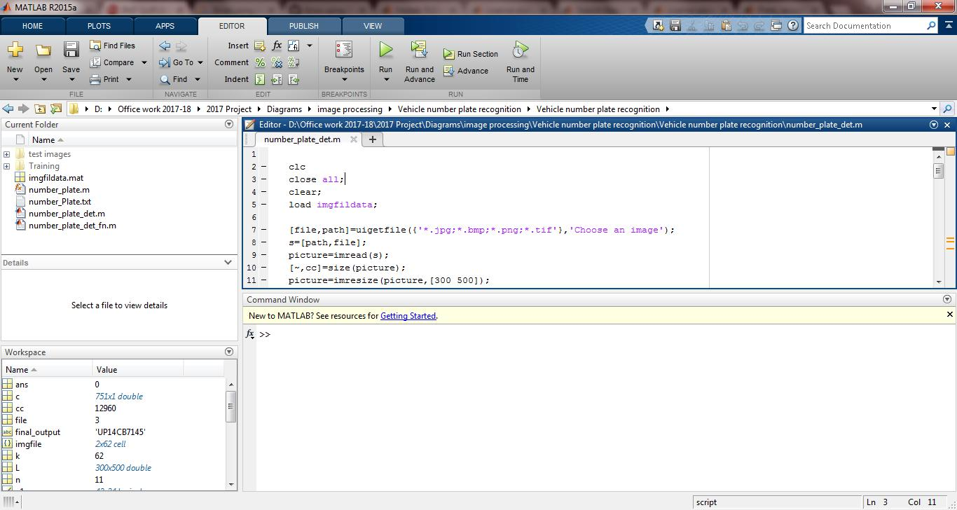

44
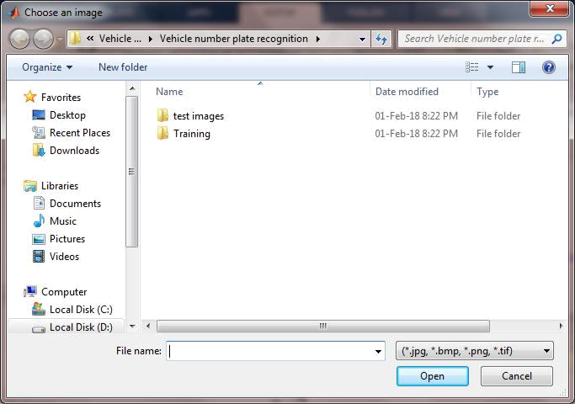

45
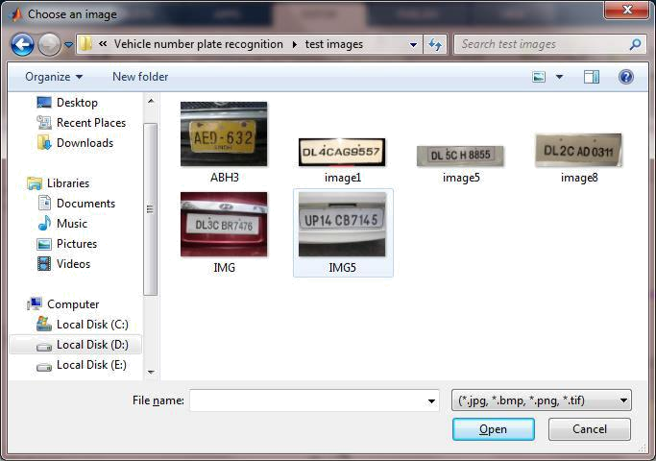

46
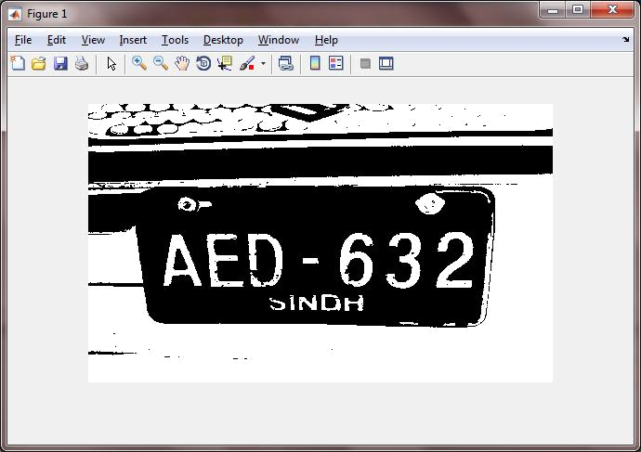

47
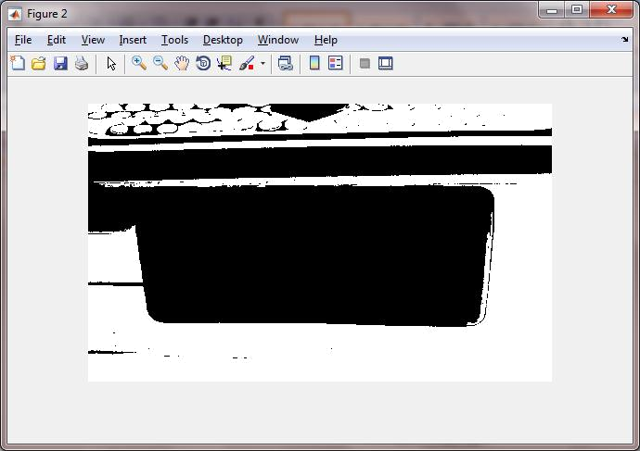

48
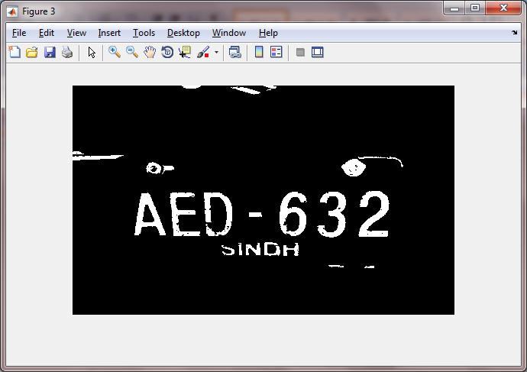

49
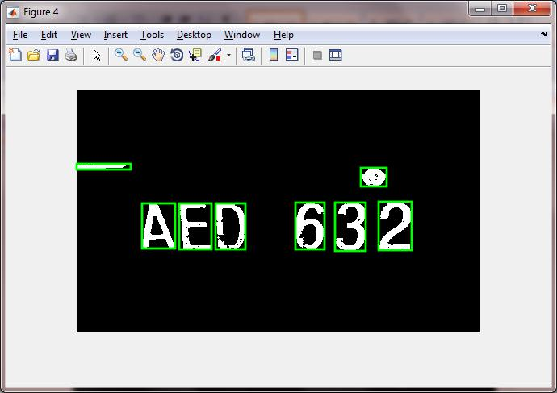

50
REFERENCES

- S.chen,H,Xu,D,Liu,B,Hu,H.Wang, “A vision of IoT: applications, challenges, and opportunities with China perspective,” IEEE Internet of Things Journal,
Vol. 1, Issue 4, pp. 349 - 359, Aug 2014.

- M. Handte, S. Foell, S. Wagner, G. Kortuem, P. Marrón; “An Internet-of-Things enabled connected navigation system for urban bus riders,” IEEE

Internet of Things Journal, Vol. 3, Issue 5, pp. 735 - 744, Oct 2016.

- B. Li, B. Tian, Q. Yao, K. Wang, “A vehicle license plate recognition system based on analysis of maximally stable extremal regions,” 9th IEEE International Conference on Networking, Sensing and Control, pp. 399 - 404, 2012.

- C. Anagnostopoulos, I. Anagnostopoulos, I. Psoroulas, V. Loumos, E.

Kayafas, “License plate recognition from still images and video sequences: a survey,” IEEE Transactions on Intelligent Transportation Systems, Vol. 9, Issue 3, pp. 377 - 391, Sept 2008.

51

52

